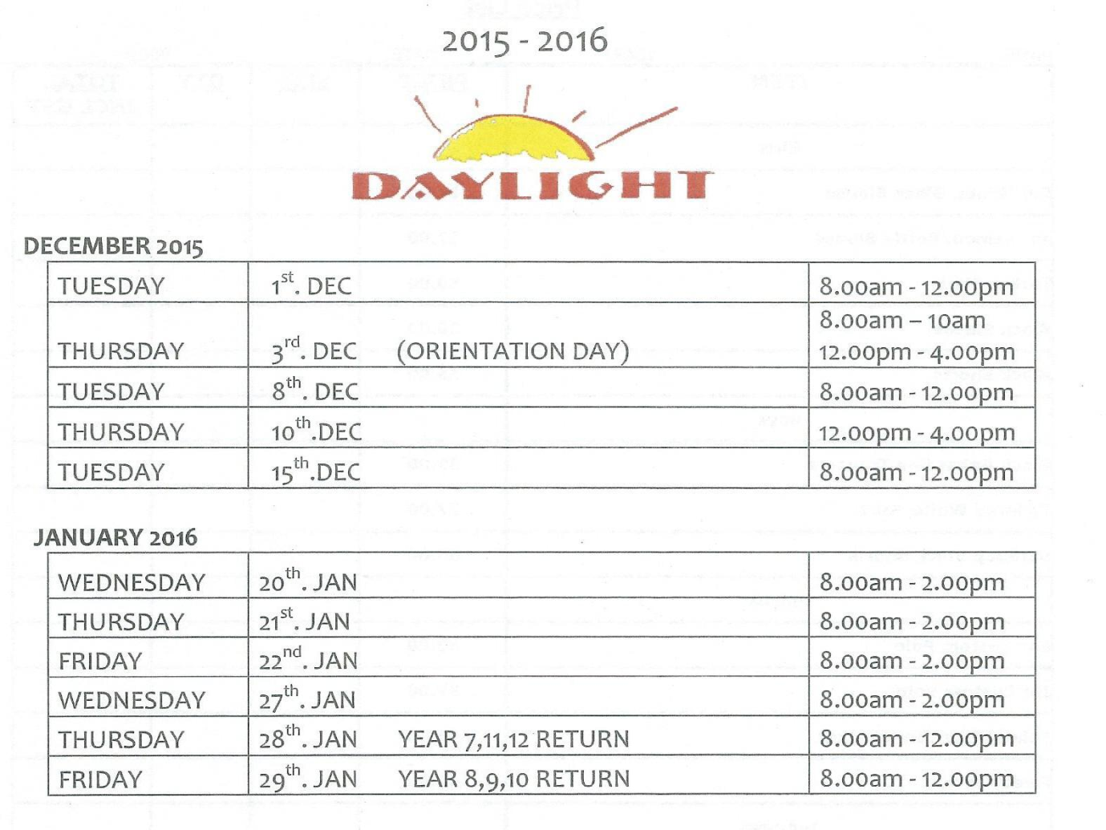

PLEASE NOTE: SHOP **NOT OPEN**

MONDAY JANUARY 25 or TUESDAY 26 JANUARY

The **Uniform shop** is located in **Quad 1**; this is behind the administration block.

**January Holidays:**

Access is through the STUDENT ENTRY GATE in Bridge Street and will be signposted. This is to the right of the main school door

There is no access from Newcastle Street

