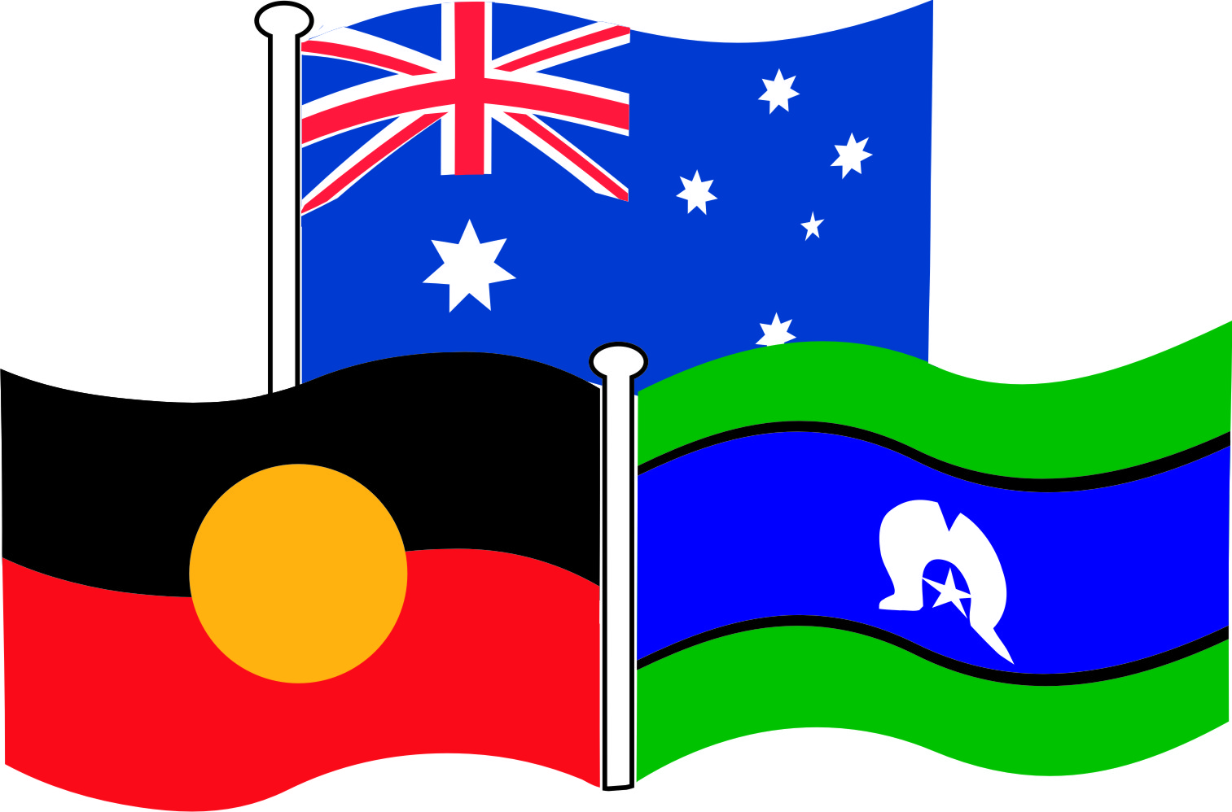Morisset High School

**Scope and Sequence**

**Year 8 HSIE 2017**

|  |  |  |  |  |  |  |  |  |  |  |  |  |  |  |  |  |  |
| --- | --- | --- | --- | --- | --- | --- | --- | --- | --- | --- | --- | --- | --- | --- | --- | --- | --- |
| **YEAR**  **8** | **Weeks** | | | | | | | | | | | | | | | | |
| **1** | | **2** | **3** | **4** | | **5** | **6** | **7** | **8** | | **9** | | **10** | | **11** |
| **Term**  **1** |  | **Topic 1 – The Western and Islamic World: Medieval Europe**  **Duration: 7 weeks**  **Lessons: 17 lessons**  **Key inquiry questions**   * How did societies change from the end of the ancient period to the beginning of the modern age? * What key beliefs and values emerged and how did they influence societies? Which significant people, groups and ideas from this period have influenced the world today?   **Outcomes:** HT4-3, HT4-5, HT4-7, HT4-8, HT4-9, HT4-10  **Task 1 Notification: Week 5, Term 1**  **Task 1 Date: Week 7, Term 1**  **Registration Due: Week 8, Term1** | | | | | | | | | | | **Topic 2 – Expanding Contacts: Black Death in Asia, Europe and Africa**  **Duration: 6 weeks**  **Lessons: 15 lessons**  **Focus Areas**   * Living conditions and religious beliefs in the 14th century * Role of expanding trade in the Black Death * The effects, causes & Symptoms of the Black Death * The long-term effects of the Black Death | | | | |
| **Term**  **2** | **Topic 2 - Expanding Contacts: Black Death (Cont)**  **Outcomes:** HT4-2, HT4-3, HT4-4, HT4-6, HT4-7, HT4-10  **Task 2 Notification: Week 2, Term 2**  **Task 2 Due: Week 4, Term 2**  **Registration Due: Week 6, Term 2** | | | | | **Topic 3 – The Asia-Pacific World: Japan under the Shoguns**  **Duration: 7 weeks**  **Lessons: 17 lessons**  **Focus Areas**   * The way of life of Shogun Japan, including social, cultural, economic and political features (including the feudal system and increasing power of the shogun). * The role of the Tokugawa Shogunate in reimposing the feudal system * The use of environment resources in Shogunate Japan * Theories about the decline of the Shogunate   **Outcomes:**  HT4-2, HT4-4, HT4-6, HT4-7, HT4-9, HT4-10  **Registration Due:** Week 10, Term 2 | | | | | | | | |  | | |
| **Term**  **3** | **Topic 1 – Global Change & Inequalities**  **Duration: 8 weeks**  **Lessons: 20 lessons**  **Focus Areas**   * The changing nature of the world and responses to these changes. * Global inequalities and extremes of poverty and wealth * Global organisations who work to reduce global inequalities   **Outcomes:** G4.1, G4.2, G4.3, G4.4, G4.5, G4.7,G4.9, G4.10  **Task 3 Notification: Week 6, Term 3**  **Task 3 Due: Week 8, Term 3**  **Registration Due: Week 10, Term 3** | | | | | | | | | | **Topic 2 –**  **Climate Change and Threatened Habitats**  **Duration:**  **10 weeks**  **Lessons: 25 lessons** | | | |  | | |
| **Term**  **4** | **Topic 2 – Climate Change and Threatened Habitats (Cont)**  **Focus Area**   * Global geographical issues and appropriate methods of citizenship for their management.   **Outcomes:** G4.2, G4.3, G4.4, G4.7, G4.8,G4.9, G4.10  **Task 4 Notification: Week 2, Term 4**  **Task 4 Date: Week 4, Term 4**  **Registration Due: Week 10, Term 4** | | | | | | | | | | **End of Year Activities** | | | |  | | |