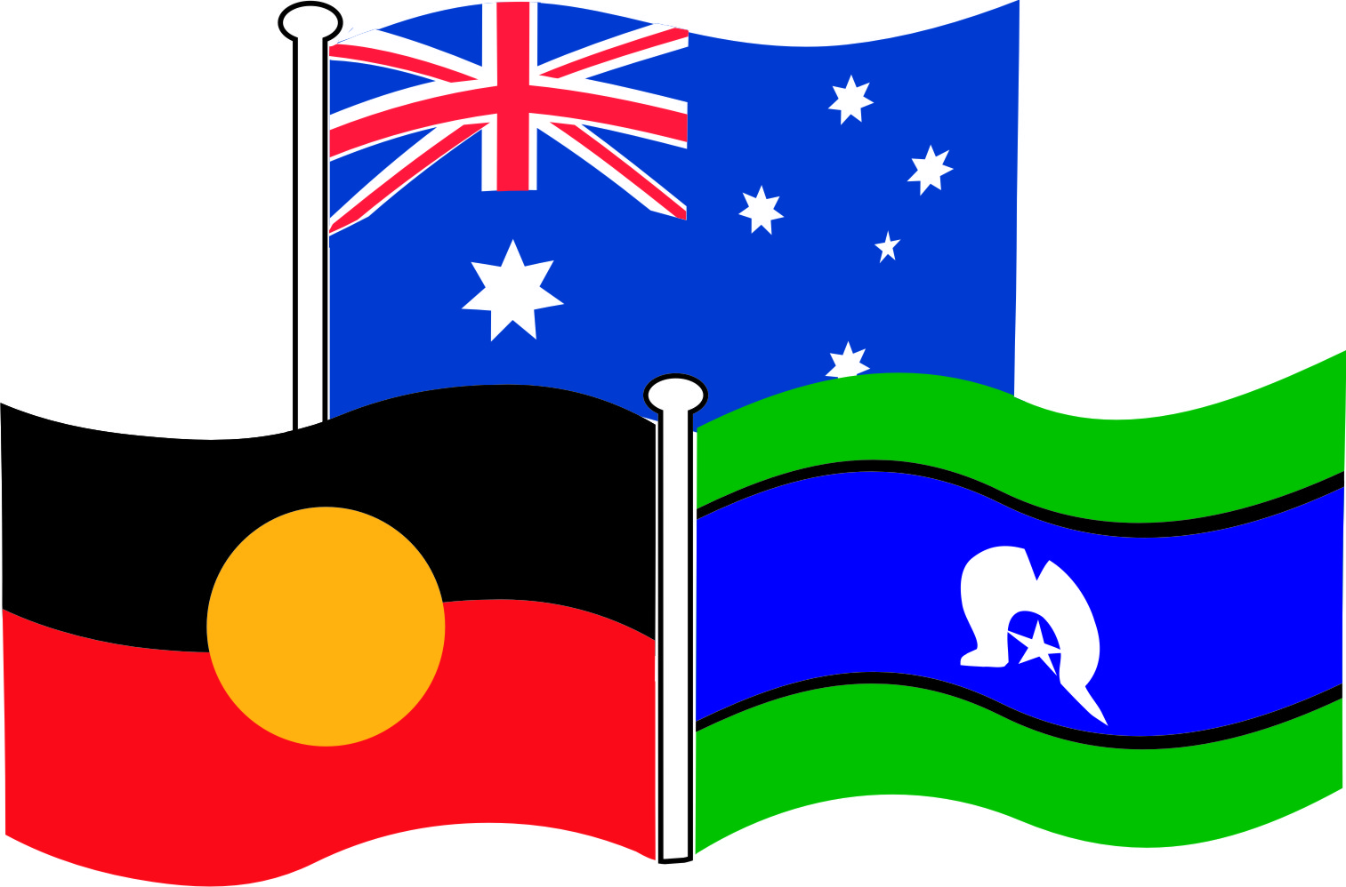Morisset High School

**Scope and Sequence**

**Year 9 Outdoor Recreation 2016**

|  |  |  |  |  |  |  |  |  |  |  |  |
| --- | --- | --- | --- | --- | --- | --- | --- | --- | --- | --- | --- |
| **YEAR**  **7** | **Weeks** | | | | | | | | | | |
| **1** | **2** | **3** | **4** | **5** | **6** | **7** | **8** | **9** | **10** | **11** |
| **Term**  **1** | **Topic:** Lifestyle, Leisure and Recreation  **Outcomes:** 2.1,2.2,4.1,4.2,4.3,4.4  **Unit Description:** Students investigate perceptions of lifestyle, leisure and recreation, patterns of participation, benefits of participation in leisure and recreation and future perspectives for lifelong leisure & recreation. | | | | | | | | | | |
| **Topic:** Individual and team building activities; strategies games snatch, chase, orienteering, dungeons and castles, capture the flag | | | | | | | | | | |
| **Term**  **2** | **Topic:**  Planning the outdoor challenge  ***Outcomes***: 1.1, 3.1, 3.2, 4.1, 4.2  ***Unit description***: Students work in teams to plan, implement and evaluate the outdoor challenge. | | | | | | | | | |  |
| **Topic:** Local Recreation  ***Outcomes***: 2.1, 2.2, 3.1, 3.2, 4.3, 4.4  ***Unit description***: Students use local resources and environment to investigate, participate and develop their skills in enjoyable recreational/leisure pursuits. Examples could include cycling/mountain biking, group exercise at local gym, skateboarding and surfboard riding. | | | | | | | | | |
| **Term**  **3** | **Topic:** Outdoor Adventure  **Outcomes:** 1.2, 1.2,3.1,3.2  **Unit description:** Students investigate maps, reading maps and map terminology. The study the importance of planning and organising outdoor experiences, what type of food, how to travel sustainable, camp fire and food. | | | | | | | | | |  |
| **Topic:** Recreational Sport  **Outcomes:** 1.2,2.1,3.1,3.2  **Unit Description:** Archery, Orienteering, relaxation, swimming, bike riding, fishing Etc. | | | | | | | | | |
| **Term**  **4** | **Topic:** First Aid  **Outcomes:** 2.1,2.2,4.1,4.2  **Unit description:** Students learn the basic first aid principles. They learn how to manage and treat injuries. | | | | | | | | | |  |
| **Topic:** Activates  ***Outcomes***: 2.1, 2.2, 3.1, 3.2, 4.3, 4.4  ***Unit description***: Students use local resources and environment to investigate, participate and develop their skills in enjoyable recreational/leisure pursuits. Focus in this unit is participating in activities that are individual and group eg racquet ball, squash, kayaking, water activates | | | | | | | | | |